Fixing Broken Windows
Restoring Order and Reducing Crime in Our Communities
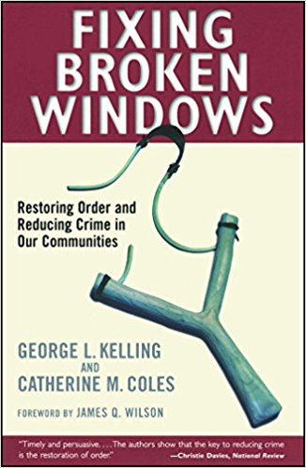
Authors: George L. Kelling & Catherine M. Coles
ISBN: 0-684-82446-9
Publisher: Free Press
Published Date: Nov. 6th, 1996
Page Count: 256

Traditional policing approaches have concentrated on reacting to crime, but the authors of Fixing Broken Windows - Restoring Order and Reducing Crime in Our Communities is about a more proactive approach. In neighborhoods, it is not only vital to reduce crime and disorder but to also reduce the fear of crime that adversely affects quality of life. The analogy of the “Broken Window” (a broken window leads to more broken windows which lead to graffiti, etc., creating an atmosphere conducive to criminal behavior) is known throughout the world. Traditional policing methods ignore crimes that affect quality of life, but the authors of Fixing Broken Windows address that head-on by using a proactive approach to preventing crime by addressing disorder. New York City has used “Broken Window Policing” by utilizing “more beat cops, more community self-policing and targeting public intoxication and antisocial behavior” generally associated with homeless individuals to effectively reduce crime and other sources of disorder. Fixing Broken Windows - Restoring Order and Reducing Crime in Our Communities is a proven “how-to” primer that should be on the bookshelf of every crime prevention practitioner in law enforcement, city planning or in the security industry.

Based on our opinions and also the reviews below, we give Fixing Broken Windows - Restoring Order and Reducing Crime in Our Communities FIVE stars.

Broken windows breed disorder, so said George L. Kelling and James Q. Wilson in a groundbreaking article for the Atlantic Monthly in 1982. Now, Kelling returns with Catherine M. Coles to call community policing and the aggressive protection of public spaces the best crime-control options available. Three-strikes-and-you're-out is fine as far as it goes, say the authors, but it focuses on punishment rather than prevention. Kelling and Coles make sensible suggestions for restoring law and order to the places where they no longer seem to exist. Their argument is aided immensely by real-life examples of how their "broken windows" strategy has reduced crime where it's been tried.
Amazon.com
“Reduce disorder and you will reduce crime.”
William Bratton, 1996
Former New York City Police Commissioner

Reviewed by:
Lawrence J. Fennelly CPOI, CSSM and Marianna A. Perry, M.S., CPP. CPOI

