Think Crime! Using Evidence, Theory and Crime Prevention Through Environmental Design (CPTED) for Planning Safer Cities

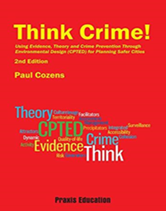

Author: Paul M. Cozens

ISBN 10: 187639403X
ISBN 13: 9781876394035
Publisher: Praxis Education, 2016

Published Date: 2016

Page Count: 194

We both really enjoyed reading this book! Why? Because it discusses the many concepts and strategies of CPTED and even though we both have quite a bit of knowledge about CPTED, each time we read this book, we learn something new.

Based on our opinions and also the reviews below, we give Think Crime! Using Evidence, Theory and Crime Prevention Through Environmental Design (CPTED) for Planning Safer Cities FIVE stars.

Review from Amazon.com:
“This book provides crucial information on CPTED and Crime Prevention for Planners, Architects, Security Professionals, Local Government planners and security managers, Police and community safety managers. Describes how to use theory and evidence in creating and justifying CPTED programs for crime prevention, improving community safety and creating safer cities. Focuses on creating effective CPTED interventions matched to each specific location or development. Describes how to undertake formal Crime Risk Assessments, and CPTED Audits.”

“Crime has a social impact, so it must be considered in the same way that impacts on the environment or health and safety risk are considered.”
British Home Office, UK

Review by:
Lawrence J. Fennelly CPOI, CSSM and Marianna A. Perry, M.S., CPP, CPOI

