PRESS RELEASE

IFPO Announces New Board Director, Ron Martin, CPP
September 18th, 2018
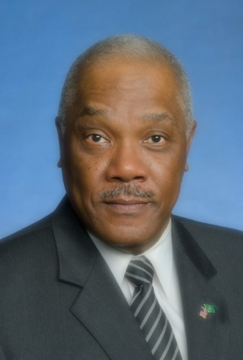
NAPLES, Fl. (September 18th, 2018) – The International Foundation for Protection Officers (IFPO) announced today the appointed of Ron Martin, CPP to the Board of Directors.
Ron is the Executive Director, of the Open Security Exchange, (OSE). OSE advocates the convergence security systems with information Technology. Through his consultancy, Ron has business relationships with a diverse mix of businesses. He served as board of director for profit and non-profit organizations. Ron retired from the United States (U. S.) Army in 1999 and the U. S. Government in 2011. In between his tours of Federal Service, he served 5 years as a civilian police officer in the Commonwealth of Virginia. During his Federal Service He served with the U. S. Department of Commerce, where he led the initial implementation of Homeland Security Presidential Directive 12 (HSPD-12). At the U. S. Department of Health and Human Services he served as the Program Director for the development and Implementation of the Department’s Identity, Credentialing and Access Management (ICAM) Program. He now serves on the Security Industry Association and ASIS International Standards Committees. Ron was recently appointed to the ASIS International’s Commission on Standards & Guidelines. Ron is a member of the ASIS International Physical Security Council and serves as ASIS International’s Regional Vice President Region 3D (Louisiana/Mississippi). He is a voting member of The United States Technical Advisory Group to International Standards Organization, (ISO) which works to develop and articulate the U.S. position by ensuring the involvement of U.S stakeholders from the private and public sectors. Ron is a member of InfraGard Louisiana Membership Alliance (ILMA) Chapter and serve as the North Louisiana Vice President. Ron serves as an Adjunct Professor at Capitol Technology University in Laurel MD. Ron holds an AAS degree from Northern Virginia Community College, a Bachelor’s degree from George Mason University and a Master of Science degree from Frostburg State University. Recently, Ron began his doctoral work at Capitol Technology University. This work will be completed soon. The Governor of the Commonwealth Kentucky designated Ron as an Honorary Kentucky Colonel for his service to the Commonwealth. In 2005 the Georgia Senate in Senate Resolution 439 recognized and commended him for his outstanding service to Augusta/Richmond County, Georgia. Additionally, he is the CEO of Consullition, LLC a Shreveport, Louisiana based consultancy.
“We are pleased to welcome Ron Martin, CPP to the IFPO’s Board of Directors,” said Mr. Dennis Shepp, CPP the IFPO Board Chairman. “Our goal is to provide educational programs and certification opportunities for security personnel. With Ron Martin’s background, knowledge, and experience, we’re excited he will help us exceed our goals.”
“We welcome Ron Martin, CPP to a dedicated and talented board,” said Sandi Davies, Executive Director of the IFPO. “We look forward to her contributions in fostering IFPO’s mission statement and Foundation objectives.”
The International Foundation for Protection Officers (IFPO) is dedicated to providing meaningful, cost effective education for all levels of security personnel. Educational institutions as well as individuals have found the IFPO Programs to be a valuable professional development tool.
We believe that education is an essential part of professional development for those charged with protecting others: The Foundation serves individuals, security service firms, and organizations that have their own security staff. Career orientated officers as well as individuals benefit from the recognition and professional standing that the Foundation certification conveys.

Contact Information
Sandi J. Davies
sandidavies@ifpo.org
239-430-0534

