|  |  |
| --- | --- |
| News Release  October 1st, 2019 | Naples, FL | cid:AC0CD8B4-66D1-4E7F-82AB-6CB0974A30DB@home |

# Bonnie S. Michleman, MS, MBA, CPP, CHPA Elected to IFPO Board of Directors

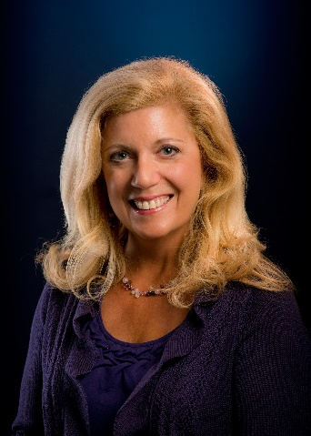IFPO Chairman of the Board Mr. Dennis Shepp announced Ms. Michelman’s appointment on October 1st, 2019. “We are thrilled to have this truly professional iconic leader join our Board.” Bonnie has extensive leadership and security management experience in diverse industries reputed to be a strong security expert nationally. She currently is the Executive Director of Police, Security and Outside Services at Massachusetts General Hospital and the Security Consultant for its parent corporation, Partners Healthcare Inc. an organization comprising 15 hospitals, hundreds of offsite facilities, and a workforce over 80,000. She oversees a licensed Police Department in this role among other departments. She was a senior executive at First Security Services Corporation (now Securitas) overseeing Security for 60 diverse operations and Assistant Vice President for General Services/Operations at Newton Wellesley Hospital managing 16 Operational and support departments. She has been an instructor at Northeastern University, College of Criminal Justice in the Graduate and Undergraduate program for over 25 years. Bonnie was appointed in 2010 by DHS Secretary Janet Napolitano to the Homeland Security Advisory Council (HSAC), holding that position until 2015 and chaired the DHS Faith Based Security Advisory Committee. Bonnie has held many leadership positions nationally, internationally and Bonnie lectures and consults on areas of healthcare security, workplace violence, hate crimes, active shooter training, domestic violence, risk assessment/management, disaster planning, leadership, change management, strategic business planning and communications.

***Bonnie S. Michelman, MS, MBA, CPP, CHPA Elected to the IFPO Board of Directors.***

**Contact Us:**

s Sandi Davies  
Executive Director  
1076 6th Avenue N.  
Naples, FL 34102f

Mr. Hurst is a proud member of the International Foundation for Protection Officers.

**Bonnie is on the Board of Directors and Past President for the International Security Management Association (ISMA). Bonnie served as President in 2001 of ASIS International. Chairman of the Board in 2002, and Foundation President from 2003 – 2005. She is Past President (2008 and 1995) as well as Chairman of the Board of the International Association for Healthcare Security and Safety (IAHSS).**

Mr. Hurst is a proud member of the International Foundation for Protection Officers.

# ________________________________________________ THE INTERNATIONAL FOUNDATION FOR PROTECTION OFFICERS:

Sandi Davies  
Executive Director  
1076 6th Avenue N.  
Naples, FL 34102  
  
**The International Foundation for Protection Officers**

239.430.0534

sandidavies@ifpo.org  
[www.ifpo.org](http://www.ifpo.org)

Mission Statement: The International Foundation for Protection Officer is committed to the support and professional development of protection officers. Through advocacy; promoting training standards; and providing accessible training, education and certification opportunities; we seek to enhance the professional standing of protection officers, as well as increase and diversify the value of the vital services they provide.