The Professional Protection Officer
Practical Security Strategies and Emerging Trends

Sandi J. Davies, Executive Director, International Foundation for Protection Officers (IFPO)
Lawrence J. Fennelly, Expert witness and consultant in security, Litigation Consultants Inc.

A Complete Resource for Protection Officer
Training and Education
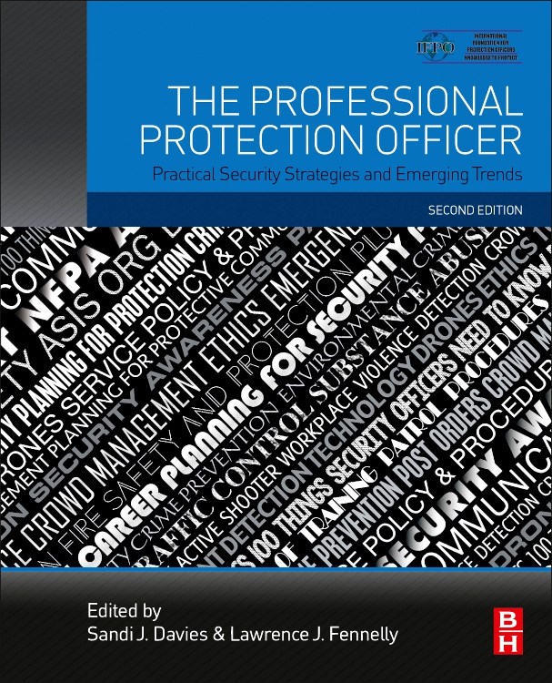

KEY FEATURES
- Offers trainers and trainees all new learning aids designed to reflect the most current information and to support and reinforce professional development
- Written by a cross-disciplinary contributor team consisting of top experts in their respective fields
DESCRIPTION
Eight previous iterations of this text have proven to be highly regarded and considered the definitive training guide and instructional text for first-line security officers in both the private and public sectors. Due to contractual agreements this edition had to be titled 2nd Edition. The material included in the newest version covers all the subjects essential to the training of protection officers. This valuable resource and its predecessors have been utilized worldwide by the International Foundation for Protection Officers since 1988, as the core curriculum for the Certified Protection Officer (CPO) Program. The Professional Protection Officer: Practical Security Strategies and Emerging Trends provides critical updates and fresh guidance, as well as diagrams and illustrations; all have been tailored to the training and certification needs of today’s protection professionals.
Please be advised the complete online program for this text is not available at this time. We anticipate a release in Q3. Until such time the previous popular online program is available and highly recommended. Paper/Pencil testing of THIS edition is available at this time.
RELATED TITLES
Fennelly, Effective Physical Security, 5e, Butterworth-Heinemann, Nov 2016, 9780128044629, 458pp, $79.95 | Davies, Women in the Security Profession, 1e, Butterworth-Heinemann, Sept 2016, 9780128038178, 290pp, $79.95 | Davies, Security Supervision and Management, 4e, Butterworth-Heinemann, Jun 2015, 9780128001134, 668pp, $74.95

ISBN: 978-0-12-817748-8
EDITION: 2
PUB DATE: December 2019
LIST PRICE: $59.95
FORMAT: Paperback
TRIM: 7.5w x 9.25h
PAGES: c. 524
PART 1: FOUNDATIONS
PART II: PRACTICAL AND OPERATIONAL APPLICATIONS
PART III: ADVANCING YOUR SECURITY CAREER

The International Foundation for Protection Officers is dedicated
to providing meaningful and cost-effective training for security
and protection officers. Visit the IFPO website at www.ifpo.
com to order copies of this book and to learn more about our programs and services.

www.elsevier.com

Detailed Table of Contents
PART 1: Foundations
1. Concepts and Theories of Asset Protection
2. Role of the Professional Protection Officer
3. The Security Officer of the 21st Century
4. Time and Stress Management
Appendix 4A - Critical Incident Stress
5. 100 Things Protection Officers Need to Know
PART II: Practical and Operational Applications
6. Occupational Health, Industrial Hazards, Vulnerability Assessment, and Self-Assessment
7. Legal Aspects of Security
8. Patrol Principles
Appendix 8A - Four Critical Points
9. The Importance of CPR/AED and First Aid Training for Security Officers
10. Officer Safety and Use of Force
11. Active Assailant Preparedness: Beyond Active Shooter Response
Appendix 11A - A Look at Solutions to Active Shooters
Appendix 11B - Saving a Life, It's in Your Hands
12. Apprehension and Detention Procedures
13. Traffic Control
14. Fire Prevention, Detection, and Response
15. Access Control
16. Contraband Detection Technology
Appendix 16A - Unmanned Aerial Vehicle (Drone) Usage in the 21st Century
17. Effective Communications
18. Crime and Incident Scene Procedures
19. Foundations for Surveillance
20. Report Writing and Field Notes
21. Crisis Intervention
Appendix 21A - Mental Illness Takes Many Forms
22. Substance Abuse
23. Investigation: Concepts and Practices for Security Professionals
Appendix 23A - ASIS International: Investigator Certification
24. Interviewing and Statements
25. Crowd Management and Special Event Planning
26. Strikes, Lockouts, and Labor Relations
27. Workplace Crime and Deviance
28. Espionage—A Primer
29. Terrorism: What Protection Officers Need to Know
30. Bomb Threats and the Case Against Immediate Evacuation
31. An All-Hazards Approach to Hazardous Materials
32. What is Risk?
Appendix 32A - What Is Risk Management?
33. Emergency Planning
34. Security Awareness
35. Building a Sustainable Culture of Security
36. The Protection Officer's Role in Critical Information Infrastructure Protection
37. Physical Security Concepts and Applications
38. Alarm System Fundamentals
39. VIP Security
40. Information Security and Counterintelligence
41. Cybersecurity for Professional Security Officers
PART III: Advancing your Security Career
42. Ethics and Professionalism
43. Networking
44. The Protection Officer as a Leader
45. Career Planning
Epilogue - Training Topics from ASIS Guideline PSO-2019
Index
www.elsevier.com

